Configure DNS settings in Azure

Resource Group: rg-Contoso
Overview: This lab hopes to configure DNS name resolution for Contoso LTD.
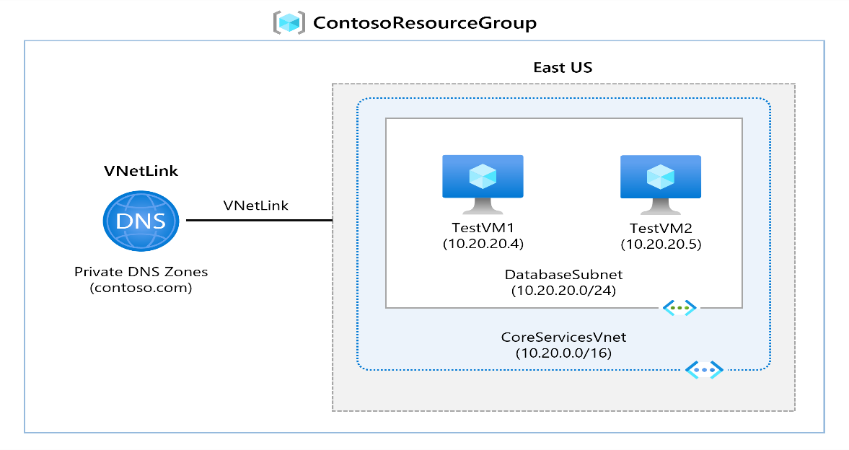
Design:

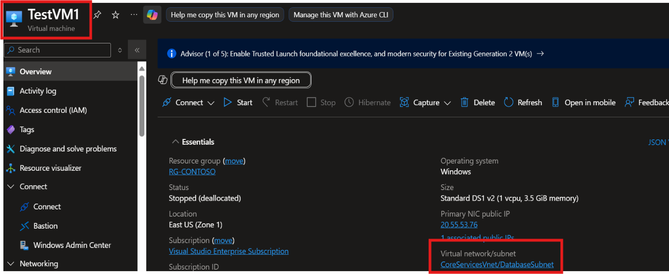
Step 1: Create two virtual machines and put it behind the CoreServicesVnet and DatabaseSubnet.

Figure 1: TestVM1 Overview
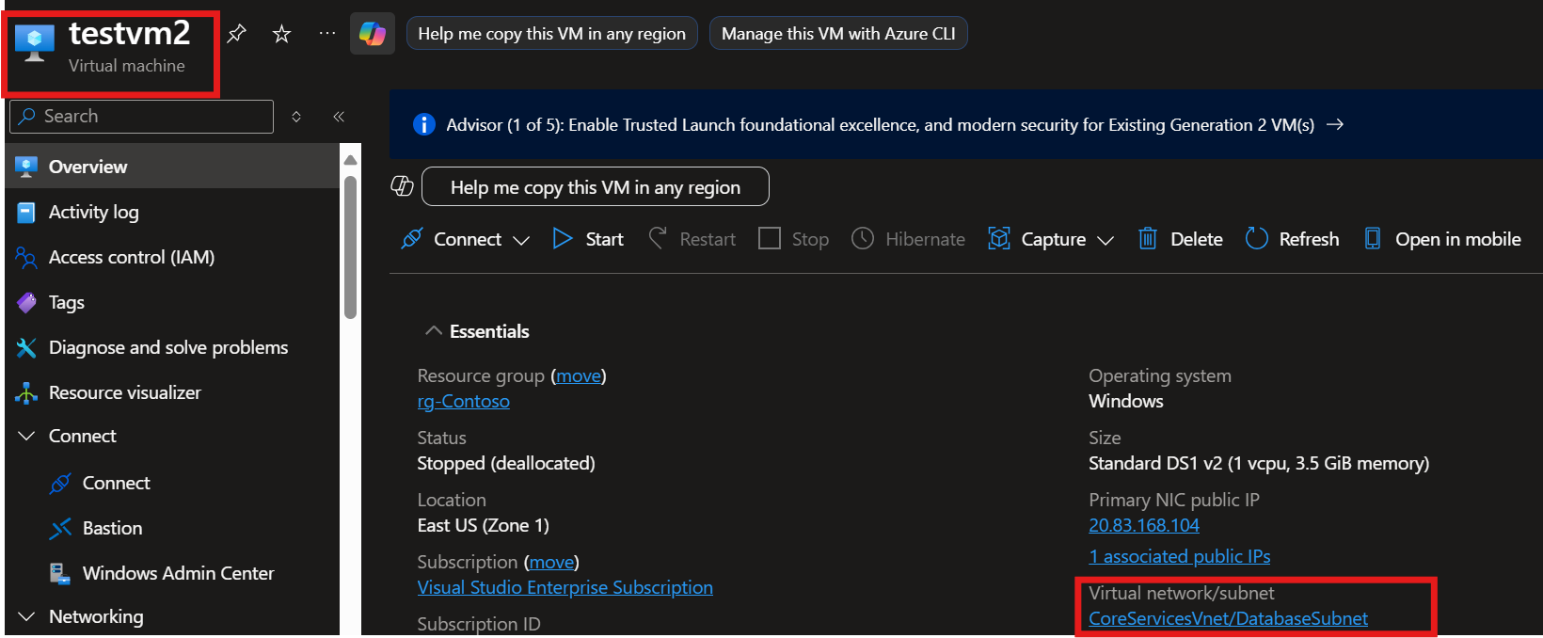
Figure 2: TestVM2 Overview

Step 2: Create Private DNS Zone named contoso.com. This will serve as the full qualified domain name for the virtual machines to resolve to.
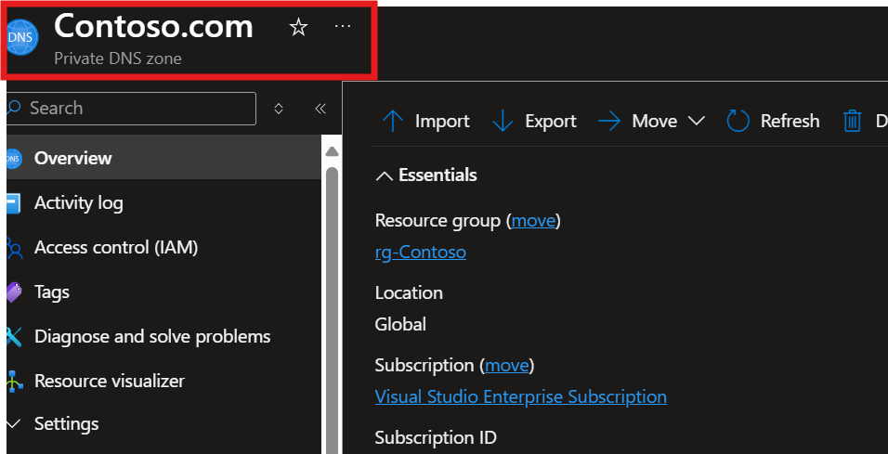

Figure 3: Private DNS Overview

Step 3: Link the private dns zone to the virtual network and enable auto registration. 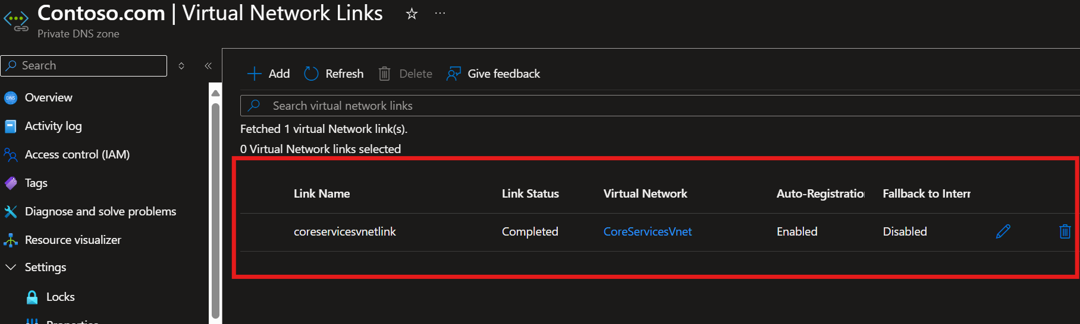
Figure 4: Virtual Network Link
Enabling the “auto-registration” allows the virtual machines associated in that vnet to register their private IP addresses, as DNS records in the private DNS zone by default.
Step 4: Verify A records exist in the private dns zone.
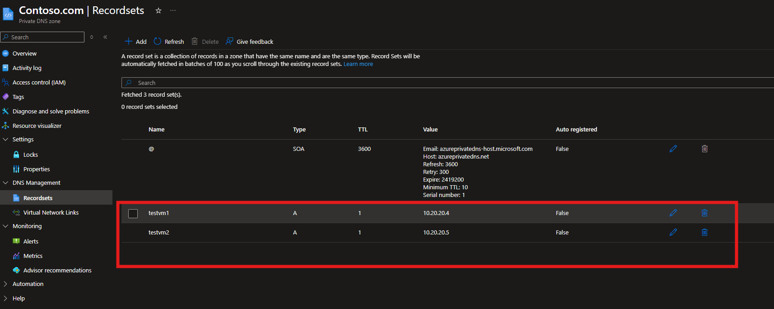
Figure 5: A records
Step 5: RDP into TestVM1. Then open command prompt and enter the command nslookup on TestVM1.contoso.com

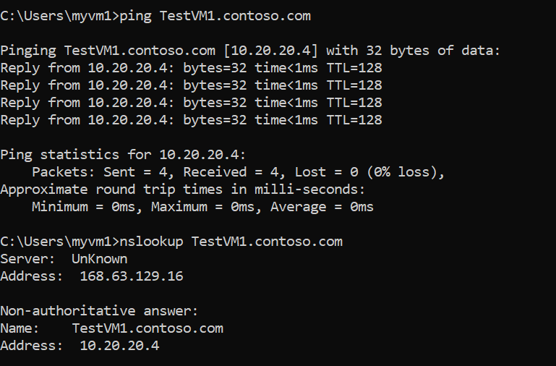

Figure 6: Nslookup on TestVM1
Step 2: RDP into TestVM2. Then open command prompt and enter the command nslookup on TestVM2.contoso.com
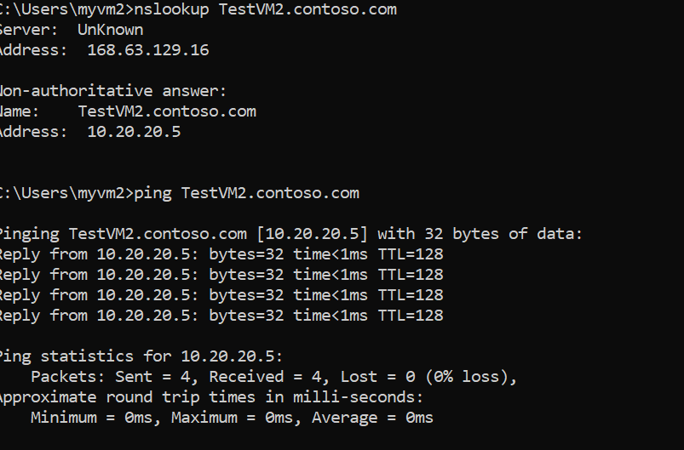

Figure 7: Nslookup on TestVM2
It’s important to do a nslookup to verify that the domain resolves the private IP. Thus, ruling out that the private DNS contoso.com works.

